Business Fundamentals writeup

*Using data from craft beer reviews, a predictive analysis on beer was performed to identify the next great NA beer*

By: Scott Turransky

**Abstract**

The goal of this project is to review a database of Craft beers found on Kaggle. This database will be assessed to identify trends in the craft beer industry. The customer is Athletic Brewing Company. They have a focus on making great NA beers. They are looking to add a new beer to their portfolio and will use the database to help see what is popular for their beer.

**Design**

The database was downloaded from a CSV file into Excel. From there, the data will be cleaned, columns will be added and prepared for analysis. Pivot tables and Excel functions were used to see relationships with the data and add new columns.

**Data**

The original CSV file from Kaggle has 3197 unique beers from 934 breweries (interestingly, Athletic was not one of those breweries). This data set contains consumer review information, as well as different tasting profiles.

Original dataset can be found here:

<https://www.kaggle.com/datasets/ruthgn/beer-profile-and-ratings-data-set>

There were over 20 columns to the original dataset. 12 of those columns used in this data analysis:

1. Style (beer Style)
2. ABV (alcohol content of beer
3. These were taste profile terms often used in the reviewer’s descriptions:
   1. Bitter
   2. Sweet
   3. Sour
   4. Salty
4. These were flavor and aroma terms used in the reviewer’s description:
   1. Fruits
   2. Hoppy
   3. Spices
   4. Malty
5. Review_taste
6. Review_overall

**Algorithms**

**The first assessment was to see if there was a beer type that was significantly more popular than other beer types. As Athletic is a NA beer company, it was important to assess the ABV for those beers to see if there was a strong correlation.**

Most beers had an average rating of 3.7-3.9. Barleywine and Strong Ale had 2 of the highest ABVs, but did not show significantly better ratings. Therefore, if it is a good beer, it will get good ratings regardless of ABV.

This was validated by comparing taste review to overall review. In the below chart, there clearly is a strong relationship between good taste and a good review. The different colors show the different beer types, while the size of the circle indicates the ABV.

**Tools**

The following tools were used:

* Dataset from Kaggle
* Excel
  + Excel functions
  + Pivot tables
  + Charts
  + Filters
* Tableau
  + Bar chart
  + Scatter plot
  + Size variances
  + Color variances

**Results**

Because Athletic is looking to add a good beer to its portfolio, its current portfolio was compared against some of the beers with the highest average scores. It did not appear they had a stout in their portfolio so that was the recommended next beer to make. To make a great stout, data for stouts with ratings of 4 or greater were assessed to see what flavor profiles were popular.

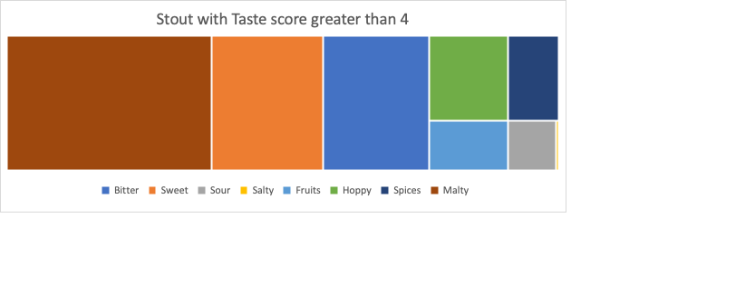

|  |  |  |  |  |  |  |  |
| --- | --- | --- | --- | --- | --- | --- | --- |
| Bitter | Sweet | Sour | Salty | Fruits | Hoppy | Spices | Malty |
| 64.696 | 67.256 | 10.752 | 0.552 | 17.384 | 30.136 | 19.464 | 124.416 |